Kathmandu University
Department of Computer Science and Engineering
Dhulikhel, Kavre


Three Dimensional Transformations
Lab Report Five
[COMP342]
(For partial fulfillment of 3rd Year/1st Semester in Computer Science)

Submitted by:
Yugesh Upadhyaya Luitel (38)

Submitted to:
Mr. Dhiraj Shrestha
Department of Computer Science and Engineering

Submission Date: December 15, 2022

Table of Contents
Chapter 1: Three Dimensional Transformation 1
1.1 Introduction 1
1.2 Additional Tools 1
1.3 Setup and Helpers 2
Chapter 2: General 3D Transformation 6
2.1 General Information 6
2.2 Source Code 6
2.3 Output 10
Chapter 3: Translation 11
3.1 Matrix 11
3.2 Code Snippet for Translation 11
3.3 Output 12
Chapter 4: Rotation 13
4.1 Matrix 13
4.2 Code Snippet for Rotation 13
4.3 Output 15
Chapter 5: Scaling 17
5.1 Matrix 17
5.2 Code Snippet for Scaling 17
5.3 Output 18
Chapter 6: Conclusion 19

Chapter 1: Three Dimensional Transformation

1.1 Introduction
3D models are a mathematical representation of a physical entity that occupies space. Three Dimensional Transformations are the processes of manipulating the view of a three-dimensional object with respect to its original position by modifying its physical attributes. These processes when applied to a point on three-dimensional space (or 3D shape, constructed using 3D points) will map it into another point in the same three-dimensional space (or 3D shape, made out of the mapped 3D points). Essentially, Three Dimensional Transformations map a set of Original Points O of a 3D Space into a set of Transformed Points T into the same 3D space.
There are various transformations that can be obtained in three-dimensional space, and through this particular lab work we aim to explore these transformations and their effects to a Three-Dimensional Cube of our choice. Amongst the various transformations, we will be looking at:
- Translation
- Rotation
- Scaling

1.2 Additional Tools
The Programming Language, Graphics Library and Tools used for the Transformations are as follows:
Programming Language: Python 3.10
Graphics Library: PyOpenGL 3.1.6
Window Renderer: GLUT
Helper Library: ctypes, numpy

1.3 Setup and Helpers
For the purpose of demonstrating the effect of various transformations, we will be using a 3D Cube with 8 vertices at (-0.5, 0.5, 0.5),(0.5, 0.5, 0.5),(-0.5, -0.5, 0.5),(0.5, -0.5, 0.5),(-0.5, 0.5, -0.5),(0.5, 0.5, -0.5),(-0.5, -0.5, -0.5),(0.5, -0.5, -0.5) in a three dimensional space. Since OpenGL does not provide its user with default three-dimensional object, the cube is drawn manually using the OpenGL’s gl.GL_TRIANGLES primitive along with indicesData to specify the vertices of 12 triangles to be drawn in order to create the various faces for a cube.
Moreover, for the purpose of implementing 3D Graphical elements, the glut.glutDisplayMode is set to glut.GLUT_DEPTH for depth buffer creation and updating. Also, to mitigate the overlapping effects , the Z Buffer test has been enabled using gl.glEnable(gl.GL_DEPTH_TEST) command.
A helper function generateCubeData() is used for the generation of the vertices of Cube, the color value for each of these vertices, and the indicesData necessary for plotting the Cube.
Code Snippet for Build Data Helper
# -- Building Data --
def generateCubeData():
data = np.zeros(8, [("position", np.float32, 3),
("color", np.float32, 4)])

data["position"] = (
(-0.5, 0.5, 0.5),
(0.5, 0.5, 0.5),
(-0.5, -0.5, 0.5),
(0.5, -0.5, 0.5),
(-0.5, 0.5, -0.5),
(0.5, 0.5, -0.5),
(-0.5, -0.5, -0.5),
(0.5, -0.5, -0.5))

data['color'] = (
(0.114, 0.505, 0.345, 1.0),
(0.483, 0.290, 0.734, 1.0),
(0.097, 0.513, 0.064, 1.0),
(0.245, 0.719, 0.592, 1.0),
(0.583, 0.771, 0.014, 1.0),
(0.473, 0.211, 0.457, 1.0),
(0.322, 0.245, 0.574, 1.0),
(0.083, 0.071, 0.014, 1.0))

indicesData = np.array([0, 1, 2, 1, 2, 3,
4, 5, 6, 5, 6, 7,
4, 2, 5, 2, 5, 1,
5, 1, 3, 5, 3, 7,
0, 4, 2, 4, 2, 6,
2, 6, 3, 6, 3, 7], np.int32)

return data, indicesData

def display():
gl.glClear(gl.GL_COLOR_BUFFER_BIT)
gl.glDrawElements(gl.GL_TRIANGLES, len(indicesData),gl.GL_UNSIGNED_INT, None)
gl.glFlush()
glut.glutSwapBuffers()

Output Cube

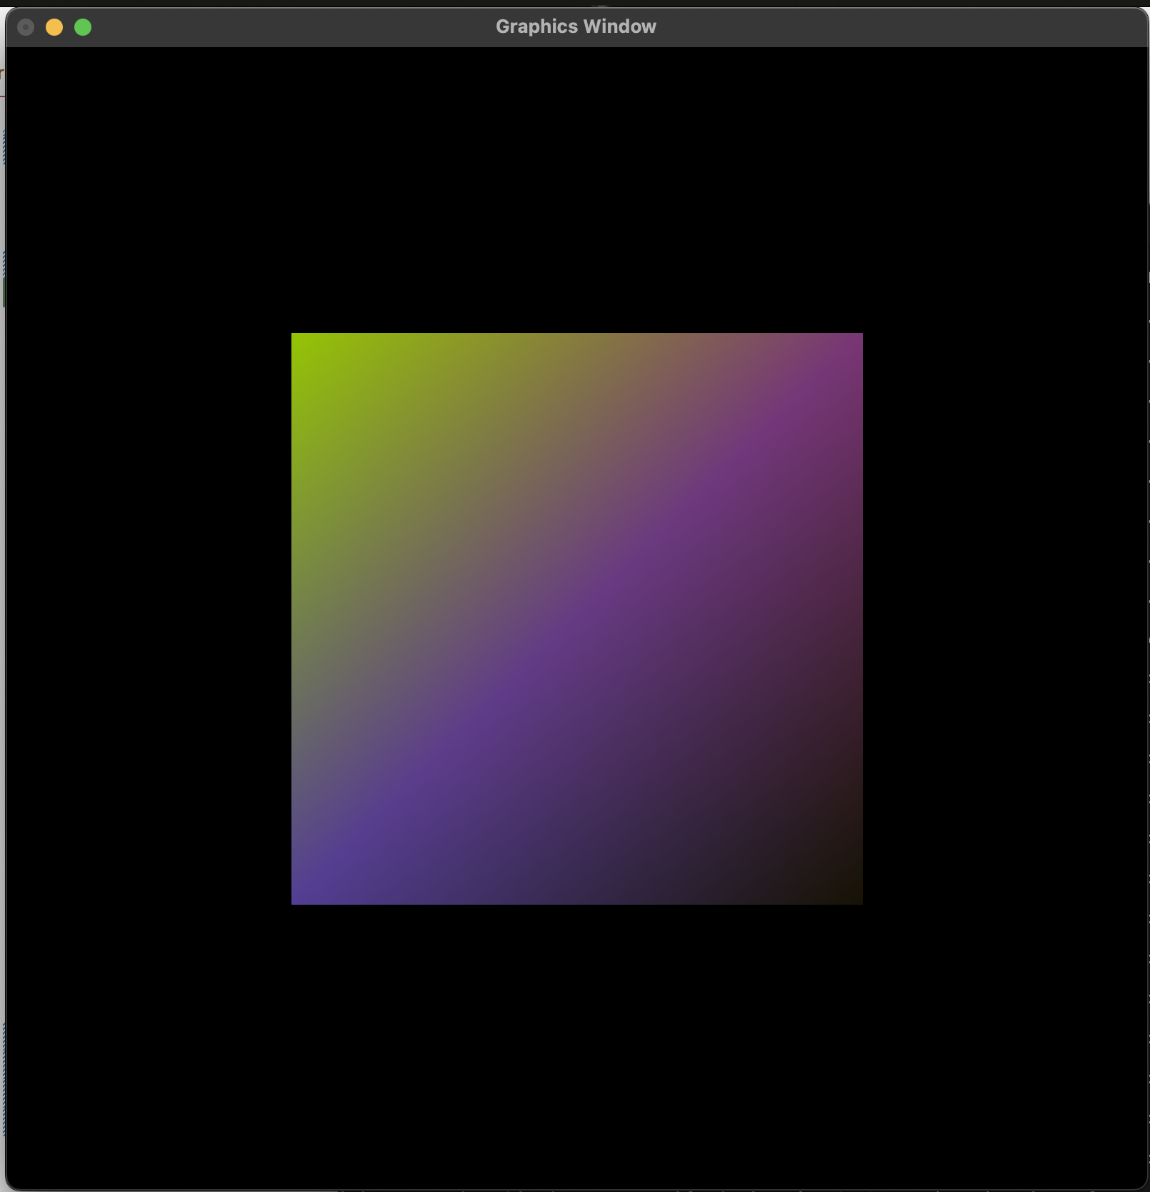

This output cube at first glance looks like a two dimensional square but this appears to be so due to the head on view onto a face of the cube, where the vertices of the faces at the back, top and sides overlap with the front face. And, since the front face has a lower z value it is shown to have blocked other views. Hence, for the purpose of this Lab Work we will be rotating this cube along both x and y axes by 40 degrees. This rotated cube will be considered the base cube for the future transformations.
40 Degrees Rotated Cube (Base Cube)

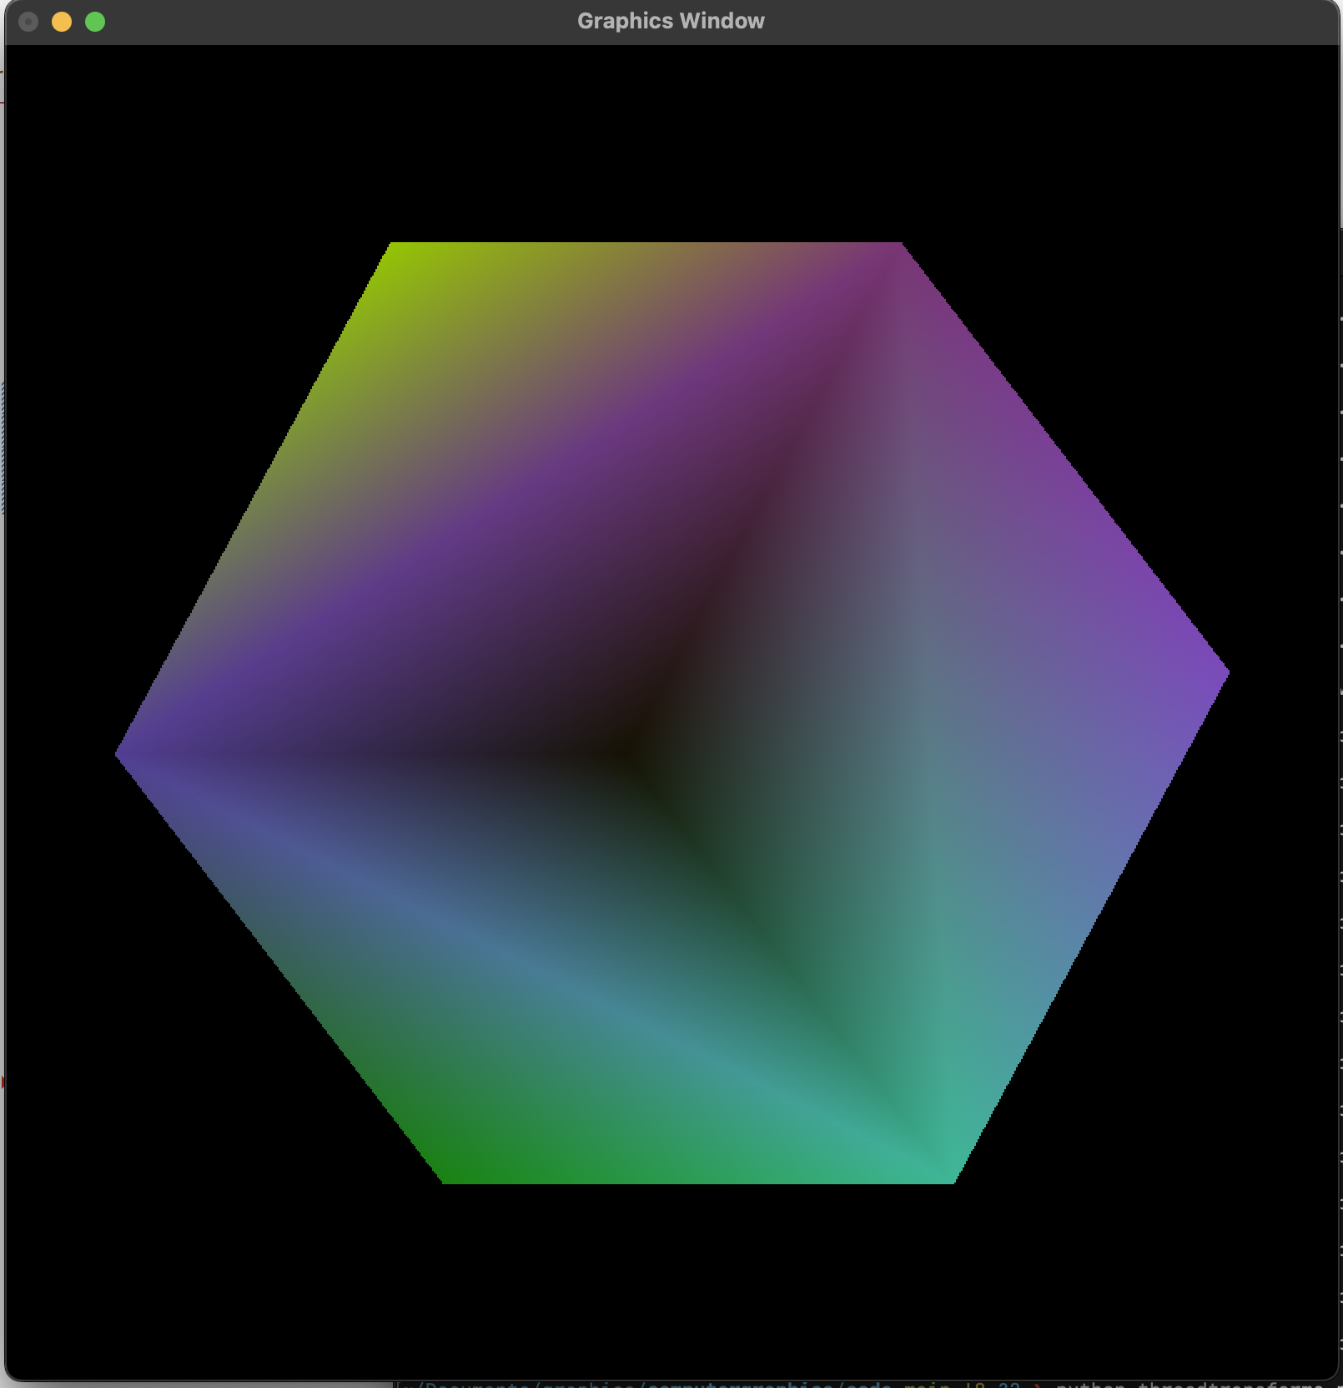

Moreover, we will be utilizing the generateTransforms() helper to build our transformation matrix based upon the transformationType and transformationData provided to it as parameters.
This helper functions looks at the transformationType parameter which is a string representing one of our 3 transformations. If it does not match with any of our defined transformations it returns an identity matrix of size (4, 4), which represents a transformation that maps the given points to themselves. Upon transformationType match, the function uses the transformationData parameter, which is a list containing all the required data necessary for that transformation, to create a transformationMatrix and return it.
The data required for transformationData parameter depending upon the type of transformation are as follows:
- Translation : transformationData=[translation in X, translation in Y, translation in Z]
- Rotation : transformationData=[(“pitch” or “yaw” or “roll”), degree of rotation]
- Scaling : transformationData=[scaling in X, scaling in Y, scaling in Z]
Code Snippet for Transformation Generation Helper

def generateTransforms(transformationType = None, transformationData = None):

transformationMatrix = np.identity(4, dtype = np.float32)
transformationMatrix = transformationMatrix.flatten()

if not transformationType:
return transformationMatrix

if transformationType == "translation":
transformationMatrix = np.array([ 1.0,0.0,0.0,transformationData[0],
0.0,1.0,0.0,transformationData[1],
0.0,0.0,1.0,transformationData[2],
0.0,0.0,0.0,1.0], np.float32)

elif transformationType == "rotation":

cTheta = np.cos(transformationData[1]/180 * math.pi)
sTheta = np.sin(transformationData[1]/180 * math.pi)

# x - axis rotation
if transformationData[0] == "pitch":
transformationMatrix = np.array([1.0,0.0,0.0,0.0,
0.0,cTheta,-sTheta,0.0,
0.0,sTheta,cTheta,0.0,
0.0,0.0,0.0,1.0], np.float32)

# y - axis rotation
elif transformationData[0] == "yaw":
transformationMatrix = np.array([cTheta,0.0,sTheta,0.0,
0.0,1.0,0.0,0.0,
-sTheta,0.0,cTheta,0.0,
0.0,0.0,0.0,1.0], np.float32)

# z - axis rotation
elif transformationData[0] == "roll":
transformationMatrix = np.array([cTheta,-sTheta,0.0,0.0,
sTheta,cTheta,0.0,0.0,
0.0,0.0,1.0,0.0,
0.0,0.0,0.0,1.0], np.float32)

elif transformationType == "scaling":
transformationMatrix = np.array([transformationData[0],0.0,0.0,0.0,
0.0,transformationData[1],0.0,0.0,
0.0,0.0,transformationData[2],0.0,
0.0,0.0,0.0,1.0], np.float32)

return transformationMatrix

Similarly, for a 3D Transformation we will be to using 4 x 4 Homogeneous Matrix to represent the Transformation Matrices. And, the data points given to the vertex shader is multipled by these homogeneous transformation matrices to get the mapped data points, which then is plotted by the vertex shader itself.
Code Snippet for Vertex Shader

vertexShaderCode = """
attribute vec3 position;
attribute vec4 color;
varying vec4 vColor;
uniform mat4 rotationMatrix[2];
uniform mat4 transformationMatrix;

void main(){
gl_Position = transformationMatrix * rotationMatrix[1] * rotationMatrix[0] * vec4(position, 1.0);
vColor = color;
}
"""

Chapter 2: General 3D Transformation

2.1 General Information
Since, the transformations using the Homogeneous Coordinate System works by cross multiplying the transformation function to the data points of our 3D Shape, we can write a general program for this multiplication. And, upon need we can vary the transformation matrix parameter to our desired one to achieve any of the described transformations, namely:
  - Translation
  - Rotation
  - Scaling

2.2 Source Code
import os
import sys
import ctypes
import numpy as np
import math

import OpenGL.GL as gl
import OpenGL.GLUT as glut
import OpenGL.GLU as glu

vertexShaderCode = """
attribute vec3 position;
attribute vec4 color;
varying vec4 vColor;
uniform mat4 rotationMatrix[2];
uniform mat4 transformationMatrix;

void main(){
gl_Position = transformationMatrix * rotationMatrix[1] * rotationMatrix[0] * vec4(position, 1.0);
vColor = color;
}
"""

fragmentShaderCode = """
varying vec4 vColor;
void main(){
gl_FragColor = vColor;
}
"""

# -- Building Data --
def generateCubeData():
data = np.zeros(8, [("position", np.float32, 3),
("color", np.float32, 4)])

data["position"] = (
(-0.5, 0.5, 0.5),
(0.5, 0.5, 0.5),
(-0.5, -0.5, 0.5),
(0.5, -0.5, 0.5),
(-0.5, 0.5, -0.5),
(0.5, 0.5, -0.5),
(-0.5, -0.5, -0.5),
(0.5, -0.5, -0.5),
)

data['color'] = (
(0.114, 0.505, 0.345, 1.0),
(0.483, 0.290, 0.734, 1.0),
(0.097, 0.513, 0.064, 1.0),
(0.245, 0.719, 0.592, 1.0),
(0.583, 0.771, 0.014, 1.0),
(0.473, 0.211, 0.457, 1.0),
(0.322, 0.245, 0.574, 1.0),
(0.083, 0.071, 0.014, 1.0),
)

indicesData = np.array([0, 1, 2, 1, 2, 3,
4, 5, 6, 5, 6, 7,
4, 2, 5, 2, 5, 1,
5, 1, 3, 5, 3, 7,
0, 4, 2, 4, 2, 6,
2, 6, 3, 6, 3, 7], np.int32)

return data, indicesData

def generateTransforms(transformationType = None, transformationData = None):

transformationMatrix = np.identity(4, dtype = np.float32)
transformationMatrix = transformationMatrix.flatten()

if not transformationType:
return transformationMatrix

if transformationType == "translation":
transformationMatrix = np.array([ 1.0,0.0,0.0,transformationData[0],
0.0,1.0,0.0,transformationData[1],
0.0,0.0,1.0,transformationData[2],
0.0,0.0,0.0,1.0], np.float32)

elif transformationType == "rotation":

cTheta = np.cos(transformationData[1]/180 * math.pi)
sTheta = np.sin(transformationData[1]/180 * math.pi)

# x - axis rotation
if transformationData[0] == "pitch":
transformationMatrix = np.array([1.0,0.0,0.0,0.0,
0.0,cTheta,-sTheta,0.0,
0.0,sTheta,cTheta,0.0,
0.0,0.0,0.0,1.0], np.float32)

# y - axis rotation
elif transformationData[0] == "yaw":
transformationMatrix = np.array([cTheta,0.0,sTheta,0.0,
0.0,1.0,0.0,0.0,
-sTheta,0.0,cTheta,0.0,
0.0,0.0,0.0,1.0], np.float32)

# z - axis rotation
elif transformationData[0] == "roll":
transformationMatrix = np.array([cTheta,-sTheta,0.0,0.0,
sTheta,cTheta,0.0,0.0,
0.0,0.0,1.0,0.0,
0.0,0.0,0.0,1.0], np.float32)

elif transformationType == "scaling":
transformationMatrix = np.array([transformationData[0],0.0,0.0,0.0,
0.0,transformationData[1],0.0,0.0,
0.0,0.0,transformationData[2],0.0,
0.0,0.0,0.0,1.0], np.float32)

return transformationMatrix

# function to request and compiler shader slots from GPU
def createShader(source, type):
# request shader
shader = gl.glCreateShader(type)

# set shader source using the code
gl.glShaderSource(shader, source)

gl.glCompileShader(shader)
if not gl.glGetShaderiv(shader, gl.GL_COMPILE_STATUS):
error = gl.glGetShaderInfoLog(shader).decode()
print(error)
raise RuntimeError(f"{source} shader compilation error")

return shader

# func to build and activate program
def createProgram(vertex, fragment):
program = gl.glCreateProgram()

# attach shader objects to the program
gl.glAttachShader(program, vertex)
gl.glAttachShader(program, fragment)

gl.glLinkProgram(program)
if not gl.glGetProgramiv(program, gl.GL_LINK_STATUS):
print(gl.glGetProgramInfoLog(program))
raise RuntimeError('Linking error')

# Get rid of shaders (no more needed)
gl.glDetachShader(program, vertex)
gl.glDetachShader(program, fragment)

return program

# initialization function
def initialize(transformationMatrix):
global program
global data

gl.glEnable(gl.GL_DEPTH_TEST)
gl.glClear(gl.GL_COLOR_BUFFER_BIT | gl.GL_DEPTH_BUFFER_BIT)
gl.glClearColor(0.0, 0.0, 0.0, 0.0)
gl.glLoadIdentity()

program = createProgram(
createShader(vertexShaderCode, gl.GL_VERTEX_SHADER),
createShader(fragmentShaderCode, gl.GL_FRAGMENT_SHADER),
)

degrees = 40
cTheta = np.cos(degrees/180 * math.pi)
sTheta = np.sin(degrees/180 * math.pi)

initialRotation = np.array([1.0,0.0,0.0,0.0,
0.0,cTheta,-sTheta,0.0,
0.0,sTheta,cTheta,0.0,
0.0,0.0,0.0,1.0], np.float32)

secondRotation = np.array([cTheta,0.0,sTheta,0.0,
0.0,1.0,0.0,0.0,
-sTheta,0.0,cTheta,0.0,
0.0,0.0,0.0,1.0], np.float32)

rotation = np.array([initialRotation, secondRotation])
# make program the default program
gl.glUseProgram(program)

buffer = gl.glGenBuffers(1)
indicesBuffer = gl.glGenBuffers(1)

# make these buffer the default one
gl.glBindBuffer(gl.GL_ARRAY_BUFFER, buffer)
gl.glBindBuffer(gl.GL_ELEMENT_ARRAY_BUFFER, indicesBuffer)

# bind the position attribute
stride = data.strides[0]
offset = ctypes.c_void_p(0)
loc = gl.glGetAttribLocation(program, "position")
gl.glEnableVertexAttribArray(loc)
gl.glBindBuffer(gl.GL_ARRAY_BUFFER, buffer)
gl.glVertexAttribPointer(loc, 3, gl.GL_FLOAT, False, stride, offset)

offset = ctypes.c_void_p(data.dtype["position"].itemsize)
loc = gl.glGetAttribLocation(program, "color")
gl.glEnableVertexAttribArray(loc)
gl.glBindBuffer(gl.GL_ARRAY_BUFFER, buffer)
gl.glVertexAttribPointer(loc, 4, gl.GL_FLOAT, False, stride, offset)

loc = gl.glGetUniformLocation(program, "rotationMatrix")
gl.glUniformMatrix4fv(loc, 2, gl.GL_TRUE, rotation)

loc = gl.glGetUniformLocation(program, "transformationMatrix")
gl.glUniformMatrix4fv(loc, 1, gl.GL_TRUE, transformationMatrix)

# Upload data
gl.glBufferData(gl.GL_ARRAY_BUFFER, data.nbytes, data, gl.GL_DYNAMIC_DRAW)
gl.glBufferData(gl.GL_ELEMENT_ARRAY_BUFFER, indicesData.nbytes, indicesData, gl.GL_STATIC_DRAW)

def display():
gl.glClear(gl.GL_COLOR_BUFFER_BIT)
gl.glDrawElements(gl.GL_TRIANGLES, len(indicesData),gl.GL_UNSIGNED_INT, None)
gl.glFlush()
glut.glutSwapBuffers()

def reshape(width,height):
gl.glViewport(0, 0, width, height)

def keyboard( key, x, y):
if key == b'\x1b':
os._exit(1)

# GLUT init
glut.glutInit()
glut.glutInitDisplayMode(glut.GLUT_DOUBLE | glut.GLUT_RGBA | glut.GLUT_DEPTH)
glut.glutCreateWindow('Graphics Window')
glut.glutReshapeWindow(800,800)
glut.glutReshapeFunc(reshape)

data, indicesData = generateCubeData()

# generate transformation matrix through paramter provision
transformationMatrix = generateTransforms()

initialize(transformationMatrix = transformationMatrix)

glut.glutDisplayFunc(display)
glut.glutPostRedisplay()
glut.glutKeyboardFunc(keyboard)

# enter the mainloop
glut.glutMainLoop()

2.3 Output
Upon execution of the above source code from the command line using python threedtransforms.py command produces the following output:
This output cube is the same one that we initially assumed to be the base cube with no further transformations applied to it. This is because in the general program we have not provided any input parameters to the generateTransforms() function.
# generate transformation matrix through paramter provision
transformationMatrix = generateTransforms()

Looking at the definition of generateTransforms() function, we can see that the transformation matrices are set to identity matrix by default meaning that upon no transformationType our transformationMatrix will return and perform identity transformation to our shape.
def generateTransforms(transformationType = None, transformationData = None):

transformationMatrix = np.identity(4, dtype = np.float32)
transformationMatrix = transformationMatrix.flatten()

if not transformationType:
return transformationMatrix

initialize(transformationMatrix = transformationMatrix)

Now, in the upcoming sections, we will be varying these transformation matrices using our generateTransforms() helper function and pass it whilst calling the initialize function to achieve our desired transformations.

Chapter 3: Translation

3.1 Matrix
To translate our Cube 0.15 in x-direction, 0.2 in y-direction and 0.2 in z-direction we generate the following 4 x 4 Homogeneous Translation Matrix:
1 | 0 | 0 | Tx
0 | 1 | 0 | Ty
0 | 0 | 1 | Tz
0 | 0 | 0 | 1
where, Tx = 0.15, Ty = 0.2, Tz = 0.2

3.2 Code Snippet for Translation
# Calculate the Transformation Matrix as follows:
transformationMatrix = generateTransforms("translation", [0.15, 0.2, 0.2])
# Pass the Transformation Matrix and Translation Matrix
# as Parameters to initialize if need be
initialize(transformationMatrix = transformationMatrix)

Description
Our code will produce the following translation numpy matrix:
transformationMatrix = np.array([ 1.0,0.0,0.0,0.15,
0.0,1.0,0.0,0.2,
0.0,0.0,1.0,0.2,
0.0,0.0,0.0,1.0], np.float32)

And, pass it to transformationMatrix parameter of the initialize() function during the call, which then feeds the matrix to the vertex shader code. Eventually, the vertex shader handles the translation through matrix multiplication.

3.3 Output
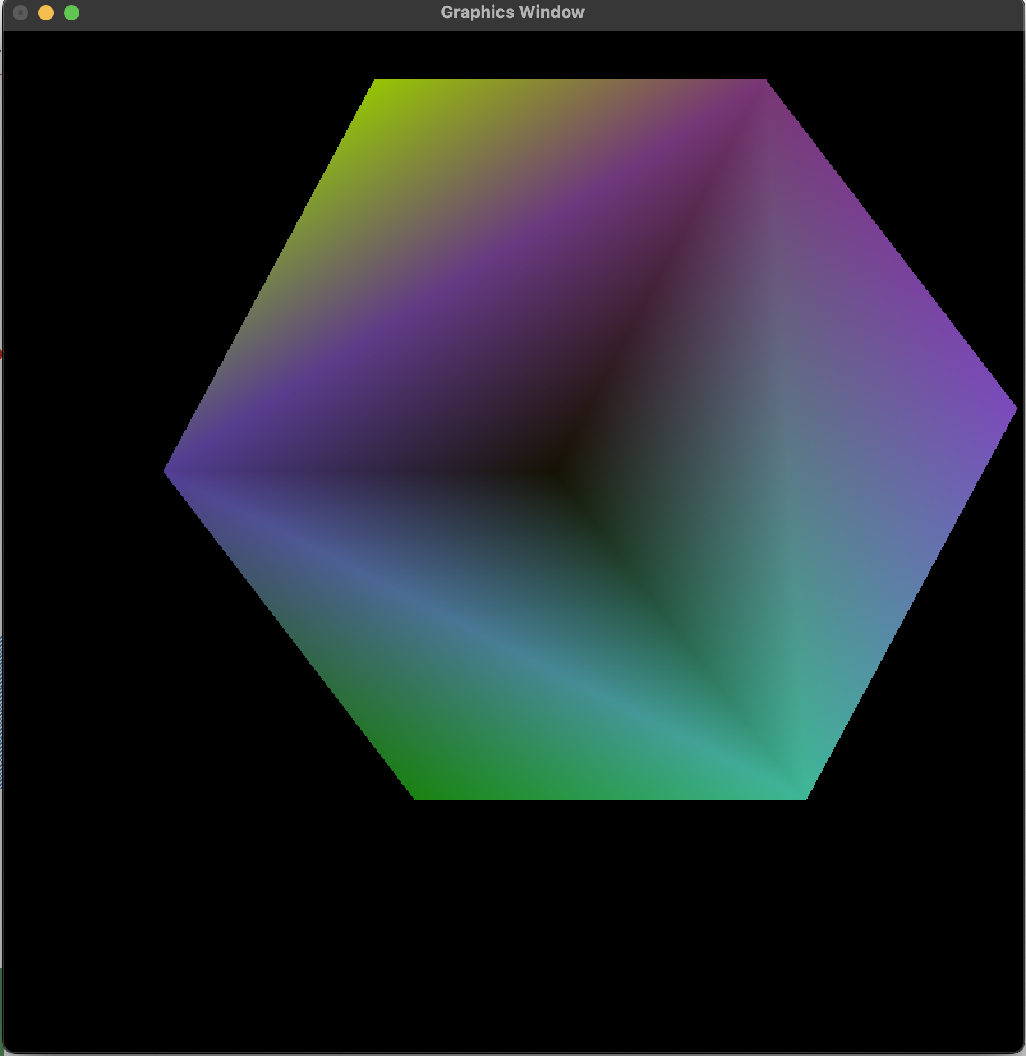
fig 3.3.1 : Before Translation fig 3.3.2 : After Translation [0.15, 0.2, 0.2]
We see no difference in the z direction translation, because the view we are looking the cube from is parallel projection so the size of the object remains the same despite the change in the z-direction values for the vertices. Since, all the vertices data are translated in z direction by same amount, the values at z buffer does change however, they change by the same amount not showing any changes in the cube faces and z direction based parameters.

Chapter 4: Rotation

4.1 Matrix
We can rotate the Cube about 3 primary axes, namely: x-axis (pitch), y-axis (yaw), and z-axis (roll). To rotate our Cube 30 degrees in each axis we generate the following 4 x 4 Homogeneous Rotation Matrices:
Rotation about x-axis Rotation about z-axis
Rotation about y-axis
1 | 0 | 0 | 0
0 | cθ | -sθ | 0
0 | sθ | cθ | 0
0 | 0 | 0 | 1
cθ | -sθ | 0 | 0
sθ | cθ | 0 | 0
0 | 0 | 1 | 0
0 | 0 | 0 | 1

cθ | 0 | sθ | 0
0 | 1 | 0 | 0
-sθ | 0 | cθ | 0
0 | 0 | 0 | 1

where, cθ = cos(θ) and sθ = sin(θ) and θ = 30 degrees

4.2 Code Snippet for Rotation
Rotation about x-axis (Pitch)
# Calculate the Transformation Matrix as follows:
transformationMatrix = generateTransforms("rotation", [“pitch”, 30])

# Pass the Transformation Matrix and Translation Matrix
# as Parameters to initialize if need be
initialize(transformationMatrix= transformationMatrix)

Rotation about y-axis (Yaw)
# Calculate the Transformation Matrix as follows:
transformationMatrix = generateTransforms("rotation", [“yaw”. 30])

# Pass the Transformation Matrix and Translation Matrix
# as Parameters to initialize if need be
initialize(transformationMatrix= transformationMatrix)

Rotation about z-axis (Roll)
# Calculate the Transformation Matrix as follows:
transformationMatrix = generateTransforms("rotation", [“roll”, 30])

# Pass the Transformation Matrix and Translation Matrix
# as Parameters to initialize if need be
initialize(transformationMatrix= transformationMatrix)
Description
Our code will produce the following rotation numpy matrices:

Rotation about x-axis (Pitch)
transformationMatrix = np.array([ 1.0,0.0,0.0,0.0,
0.0, 0.866,-0.5,0.0,
0.0,0.5,0.866,0.0,
0.0,0.0,0.0,1.0], np.float32)

Rotation about y-axis (Yaw)
transformationMatrix = np.array([ 0.866,0.0,0.5,0.0,
0.0,1.0,0.0,0.0,
-0.5,0.0,0.866,0.0,
0.0,0.0,0.0,1.0], np.float32)

Rotation about z-axis (Roll)
transformationMatrix = np.array([ 0.866,-0.5,0.0,0.0,
0.5,0.866,0.0,0.0,
0.0,0.0,1.0,0.0,
0.0,0.0,0.0,1.0], np.float32)

And, pass it to transformationMatrix parameter of the initialize() function during the call, which then feeds the matrix to the vertex shader code. Eventually, the vertex shader handles the rotation about the respective axes through matrix multiplications.

4.3 Output
Rotation about x-axis (Pitch)
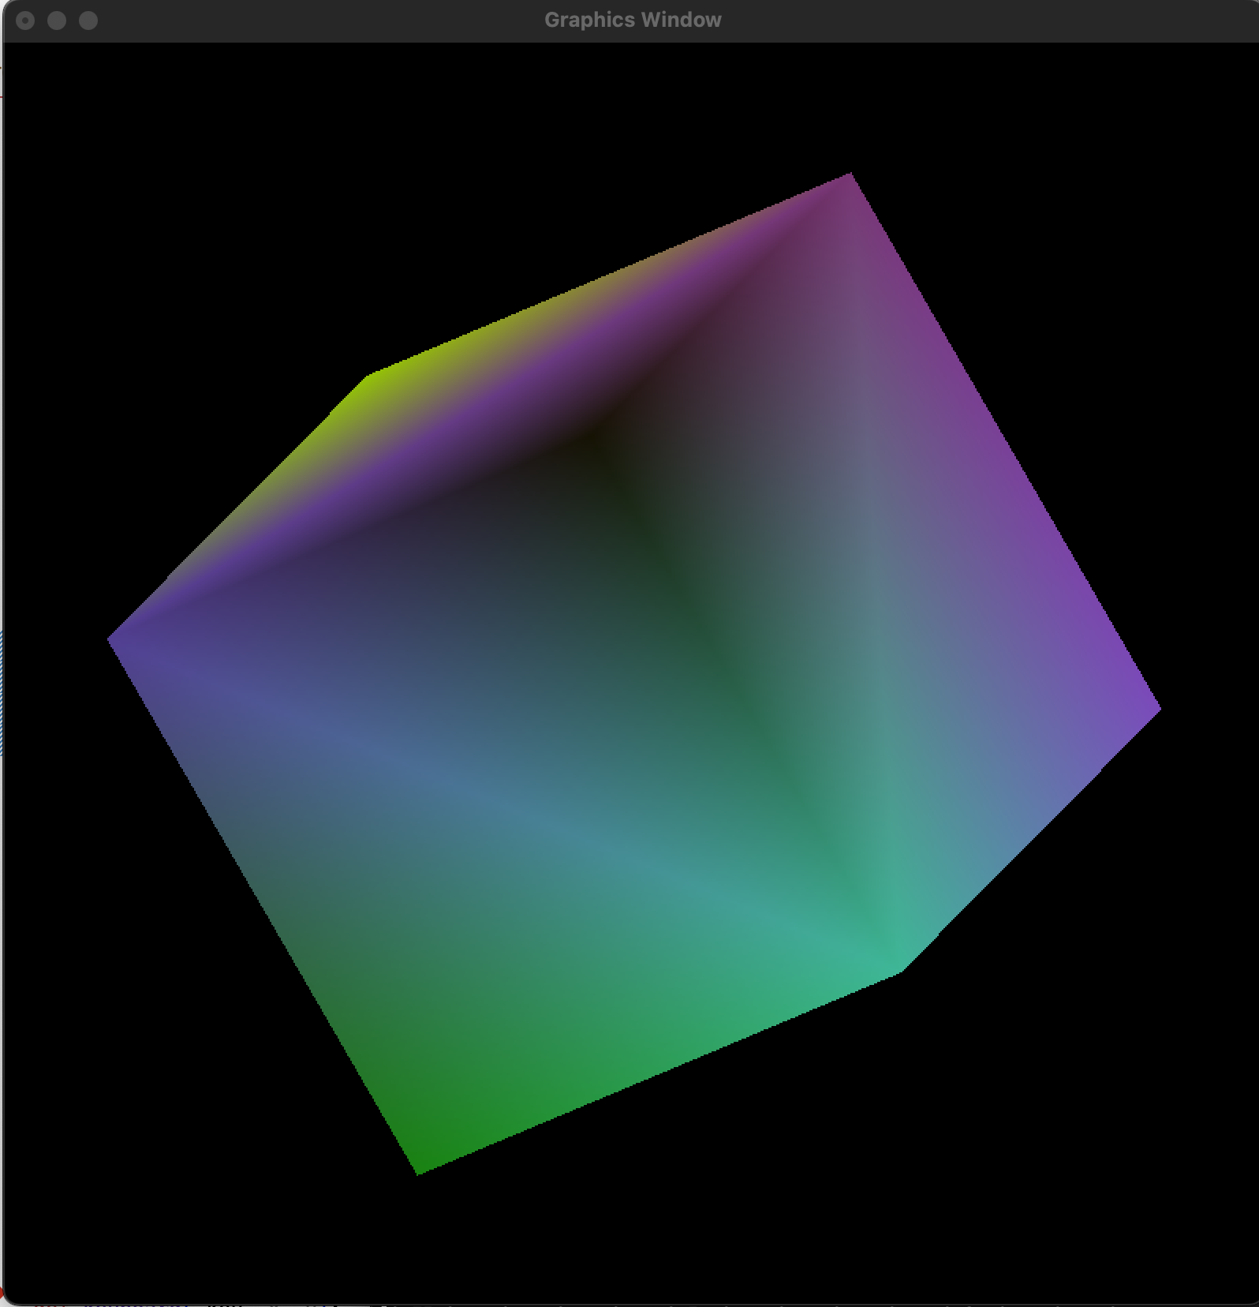
.. fig 4.3.1 : Before Rotation . fig 4.3.2 : After 30 degrees Rotation about x-axis
Rotation about y-axis (yaw)
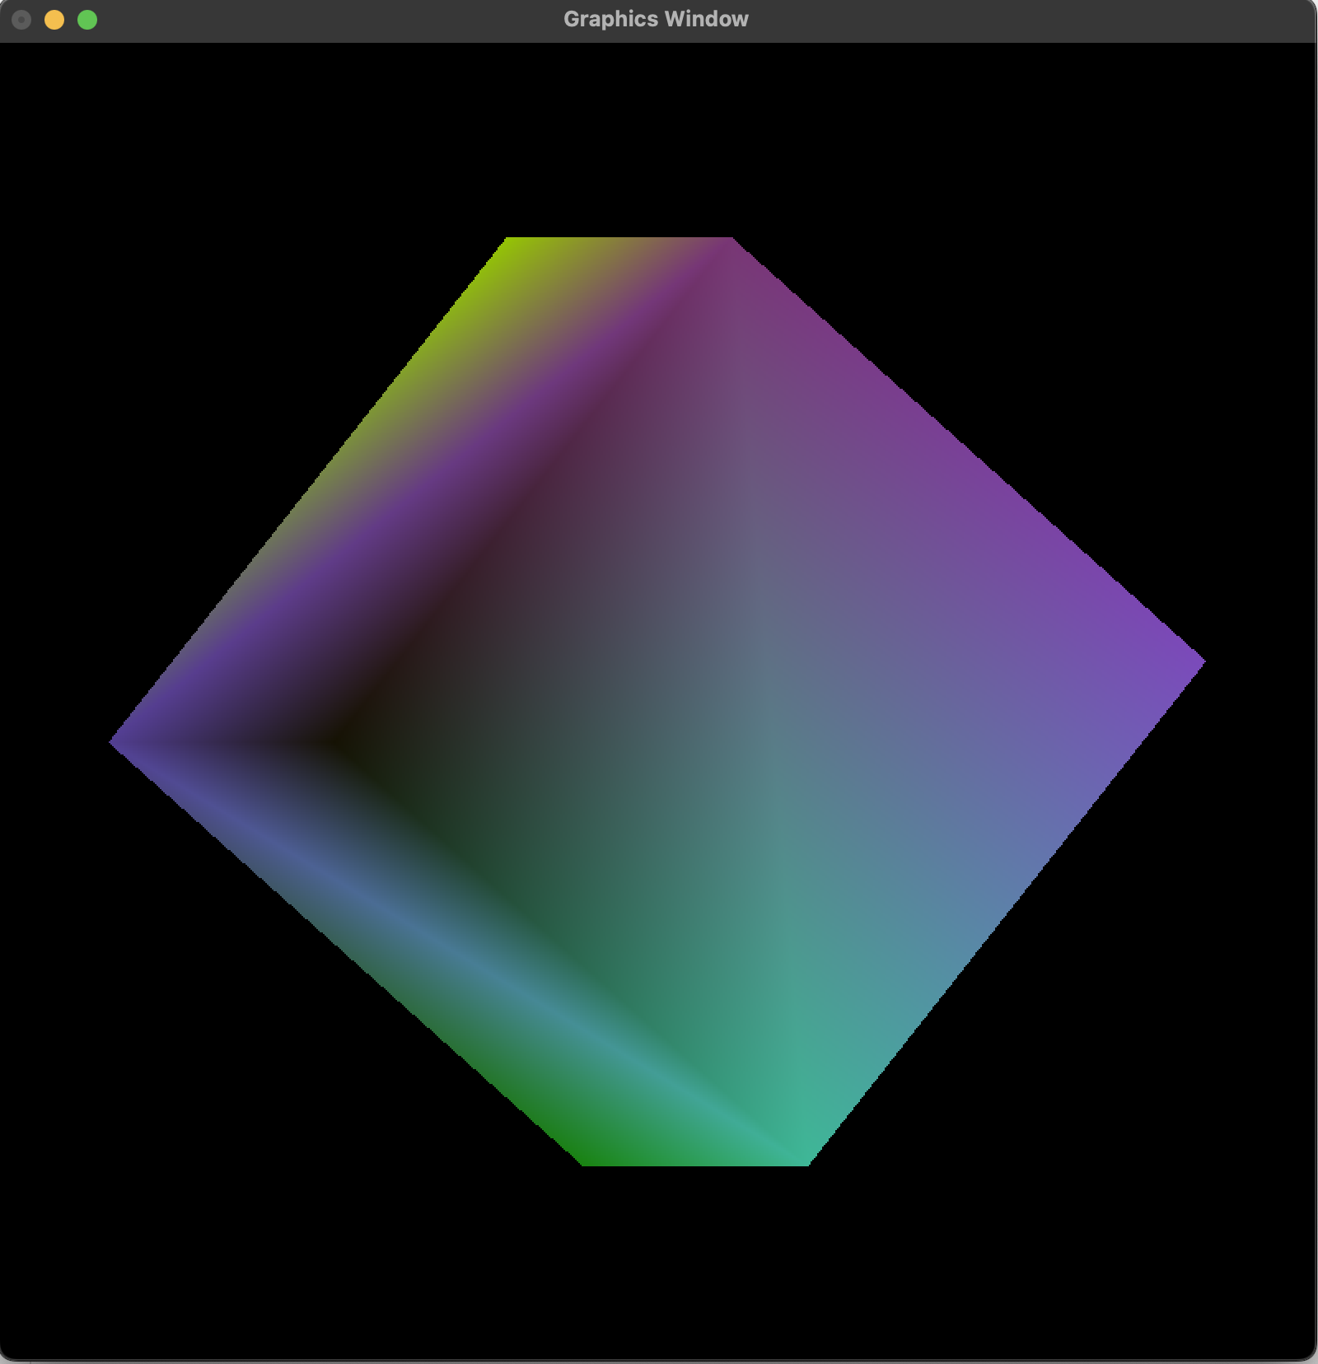
.. fig 4.3.3 : Before Rotation . fig 4.3.4 : After 30 degrees Rotation about y-axis

Rotation about z-axis (Roll)
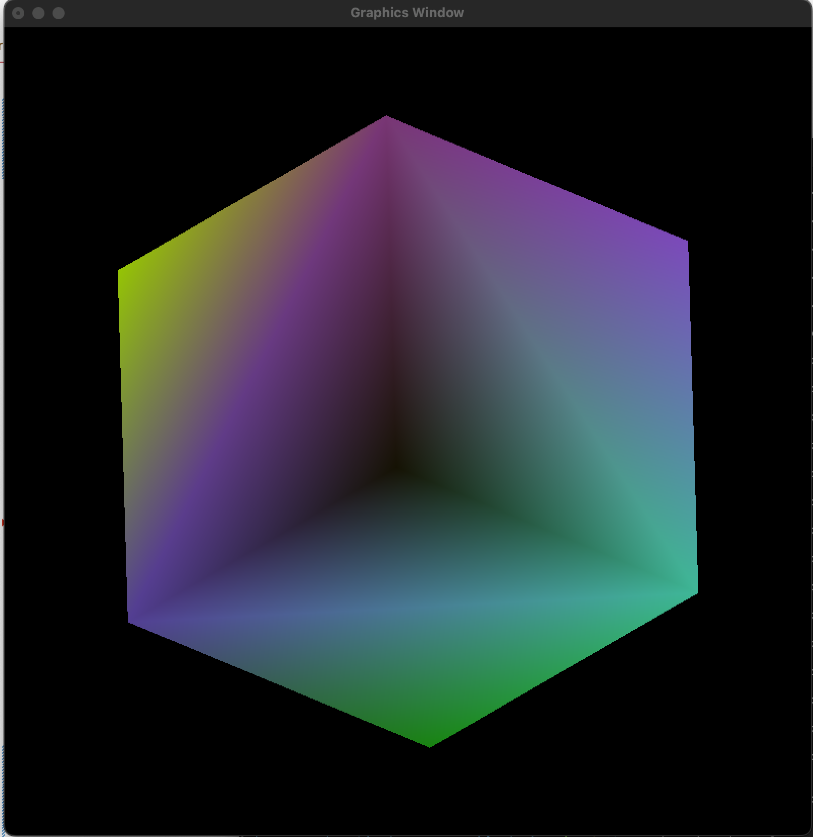
.. fig 4.3.5 : Before Rotation . fig 4.3.6 : After 30 degrees Rotation about z-axis

Chapter 5: Scaling

5.1 Matrix
To Scale our Cube by 0.8 times in x-direction, 0.6 times in y-direction and 0.6 times in z-direction we generate following 4 x 4 Homogeneous Translation Matrix and Scaling Matrix:
Scaling Matrix
Sx | 0 | 0 | 0
0 | Sy | 0 | 0
0 | 0 | 0 | 0
0 | 0 | 0 | 1

where, Sx = 0.8, Sy = 0.6 and Sz = 0.6

5.2 Code Snippet for Scaling
# Calculate the Transformation Matrix as follows:
transformationMatrix = generateTransforms("scaling", [0.8, 0.6, 0.6])
# Pass the Transformation Matrix and Translation Matrix
# as Parameters to initialize if need be
initialize(transformationMatrix = transformationMatrix)

Description
Our code will produce the following translation numpy matrix:
transformationMatrix = np.array([ 0.8,0.0,0.0,0.0,
0.0,0.6,0.0,0.0,
0.0,0.0,0.6,0.0,
0.0,0.0,0.0,1.0], np.float32)

And, pass it to transformationMatrix and translationMatrix parameter of the initialize() function during the call, which then feeds these matrices to the vertex shader code. Eventually, the vertex shader handles scaling of the cube through matrix multiplication.

5.3 Output
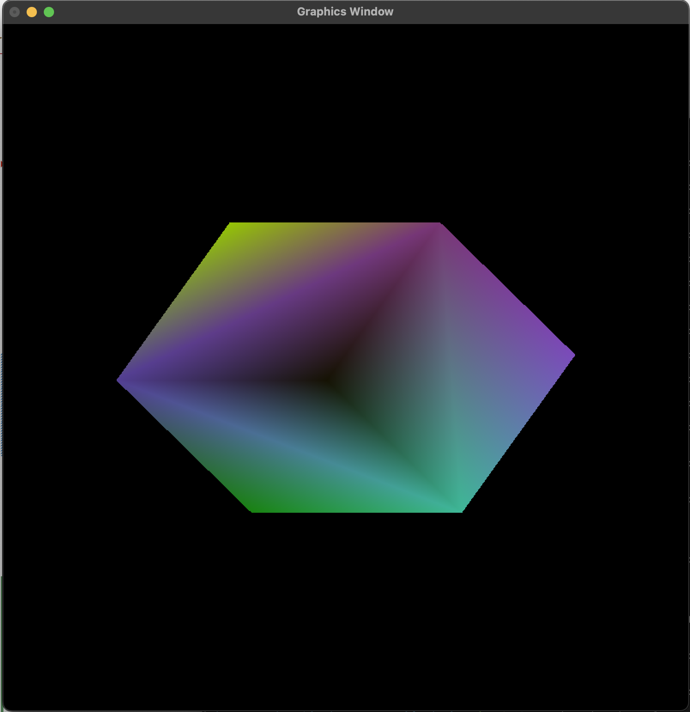
fig 5.3.1 : Before Scaling fig 5.3.2 : After Scaling [0.8, 0.6, 0.6]

Chapter 6: Conclusion
Through this Lab Work, I was able to realize the ease of using homogeneous coordinate and matrix system for implementing various transformations for a 3D Shape (Cube) in three-dimensional space. Moreover, I was also able to picturize the unrealistic appearance of a 3D Shape portrayed using parallel projection method, and the need to have an implementation for perspective projections for all 3D Graphical Systems.
Also, GLSL (OpenGL Shading Language) is written for the purpose of graphical manipulation, it automatically handles the matrix multiplications meaning transformations of a shape only needed the correct creation of transformation matrix and identification of correct order for matrix multiplications. Even though, achieving various transformations were simple, this comprehensive lab work will be extremely crucial for the implementation of our selected topic for the mini project.

